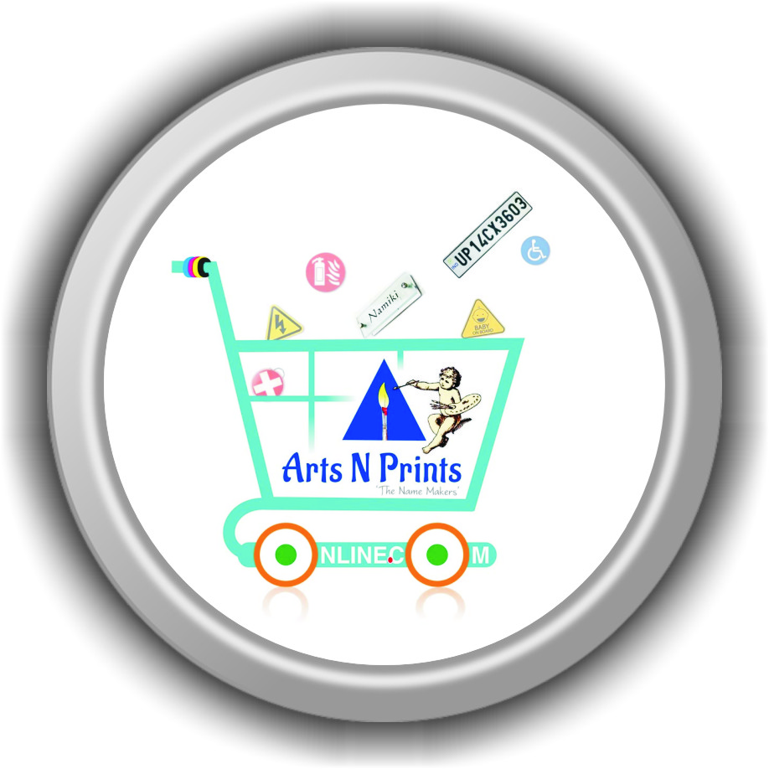

**Join artsnprints.com | a brand from Newtech as a Relationship Officer for Clients and FOES | 6 Position Opened | Immediately Joining |**

An employee who works at various branches, tasks, times, or locations, as required by an company.  Being a Sales department Relationship Officer, required to be knowledgeable of all duty & jobs within the department and should able to fill in or “float” from one branch to the next when and if need. Under indirect supervision of the project manager and team head, will provide support in various sales and booking custom orders based on daily sales needs. By performing the following duties in either the booking custom orders, promotions etc…

**JOB DESCRIPTION**

SUMMARY: The Operational and Sales, Relationship Officer is responsible for supporting the efficient operation of the branches by working in three primary areas:

1) Conducting physical visit and facilitating the movement of front office executive sales through our High Touch Convenient Stores across city.

2) Training FOES the category and product knowledge, digital payments training from POS devices, performing targets, promotion of HTS location in internet and maintaining an report of branch business.

3) Visiting customer sites for booking print on demand custom orders, with in a 1km near by branches or on the way to HTCS, as per schedule or on overnight assignments.

The Operational Vagabonds/Floaters must be skilled and knowledgeable in all three areas of the HTCS, Products and sales department. and at times may assist with shipping when directed by the backend operation team. Booking Print on demand custom products orders and services using solid arguments to prospective customers. Performing cost-benefit analyses of existing and potential customers. Maintaining positive business relationships to ensure future sales.



**Position Requirements**

**QUALIFICATIONS & EXPERIENCE:**

High quality customer services skills

Excellent people skills

Proven team member with high integrity

Proven attention to detail

Experience with driving a strong plus

Ability to navigate, follow directions, and use GPS.

Clean driving record required; Must be able to obtain DOT Certification

Experience with, inventory, testing, shipping and manufacturing of print and signages.

Proficiency with troubleshooting computer hardware a plus

Internally motivated to accomplish tasks on time

Ability to work well in a collaborative environment

Flexibility and capability to work on a variety of tasks which change often

Proficient using computers to aid in activities; including use of database, email, Internet, Microsoft Word, and Excel and other applications



**ESSENTIAL DUTIES:**

1. Training, Reporting, Inventory (competencies include attention to detail, technical aptitude, priority setting)

Accurately record and track sales through an Customer Relationship Management system in the HTS or at a customer’s site

Efficiently control and manage the receipt of booking custom orders at Newtech

Appropriately book and stage custom order for processing

2. Refurbishing (competencies include problem solving, technical skills)

Test products and record diagnostic information about quality.

Understand and comply with Newtech’s Data Security Policies and Procedures

Stage and prepare processed products for shipment

3. Customer Pickups and Driving (competencies include customer service, safety, decision making)

Provide direct service to customers at site by promoting a positive image of Newtech, answering customer’s questions, follow-up with customers when they have logistics questions, work with backend to ensure items are delivered as requested.

Pack and dispatch customer orders safely and securely

Operate Newtech’s equipment in a safe and proper manner

Maintain clean driving record

4. Branch duties

Maintain a clean and safe working environment

Understands and upholds all Newtech safety policies and compliance standards.

Package and prepare Parcels for shipment.

Other duties as assigned



**PHYSICAL DEMANDS AND WORK ENVIRONMENT**

Physical demands and work environment characteristics described here are representative of those that must be met by an employee to successfully perform the essential functions of this job.

Physical Demands: This is a job done while sitting in a branch for long periods of time. The essential equipment used is laptop and mobile phone, internet.

Vagabonds / Floaters are expected to meet or exceed the standards of Products. (accuracy and orders reported  per HTCS), delivery (accuracy and number of units delivery per FOES), shipping (safety, accuracy, loading and packaging of products in various locations), and installation (accuracy and  per hour) within the first three months of employment. The product knowledge and booking custom orders, equipment used, process, raw materials details and checklist, and measurements varies in weight and size. This job requires regular riding to branches at different locations across city. Laptop and internet connectivity is mandatory.

Work Environment: While performing the duties of this job, the employee is exposed to various customer locations and on site requirements, dust, moderate noise levels and will be required to use personal protective equipment.

artsnprints.com | a brand of Newtech is an Equal Opportunity Employer.  It is the policy of NEWTECH to provide an equal employment opportunity without regard to race, color, religion, gender, national origin, age, handicap, disability, veteran status or any other legally protected status.

Share your resume to hr@artsnprints.com |connect us on what’s app 8151828200 for direct message.