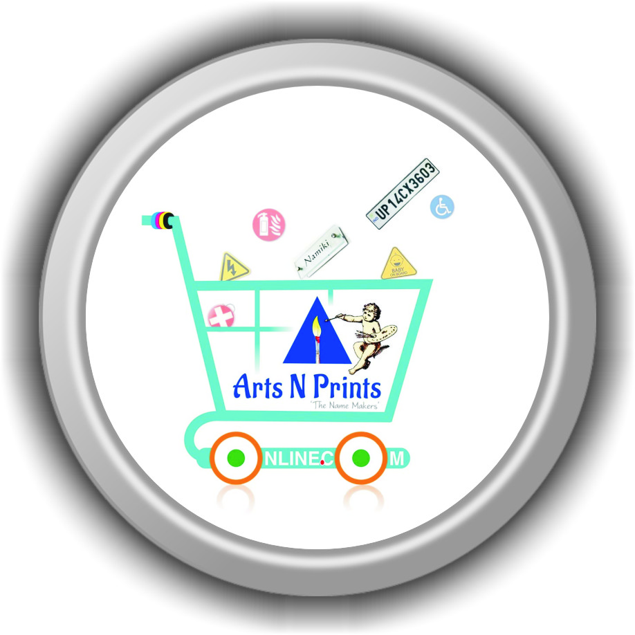
FAQ Front Office Executive Sales at High Touch Convenient Store?
artnsprints.com |
- What is the duty of front office?
- What are the front office personalities?
- What are the front office operations?
- What are the areas of front office?
- What is front office hierarchy?
- What is front office technology?
- Who is head of front office department?
- What are the duties and responsibilities of front office executive?
- What is front office a risk?
- What is front office a benefits?
- What is front office a daily task?
- What is Treasury front office?
- What is back office and front office in HTCS?
- What is front middle and back office?
- How do I become a good front office executive?
- What skills do you need to work front office executive sales?
- How can I improve my company front office service?
- How do I train myself for front office executive sales post?
- How do I organize my front office in HTCS?
- What makes a good front office executive?
- What is front office executive sales job?
- What is the average salary for front office executive sales?
- What is the average quarterly incentives for front office executive sales?
- What is the average yearly bonus for front office executive sales?
- What is the average daily perks for front office executive sales?
- What is the duty hours of front office?
- How many paid unpaid holidays for front office executive sales?
- How many hours per day front office executives work from office?
- How much can a front office executive earn in a month?
- What is the most important skill of front office executive sales?
- Why the front office position is so important?
- What are good qualities of front office executive sales?
- What skills do you need to be front office executive sales?
- What are your strengths as front office executive sales?
- What are the tasks of front office executive sales?
- What is expected of front office executive sales?
- What are common weaknesses?
- What are your top 3 skills?
- What is front office communication?
- What are the 10 types of communication?
- What are the challenges of a Front office executive?
- How do you handle a front desk?
- What are some of the organizational concerns of front desk design?
- What are the basic function of front office?
- What are the qualities of front office staff?
- What are the types of front office?
- What are the front office procedures?
- What is the career path for a front office executive?
- Is front office executive a stressful job?
- Is front office executive a female job?
- Is a front office executive a professional job?
- Should a front office executive eat at her desk?
- How can a receptionist add value to a company?
- How do front office executive best contribute at work?
- What computer skills does a front office executive need?
- How do front office executive show value at work?

