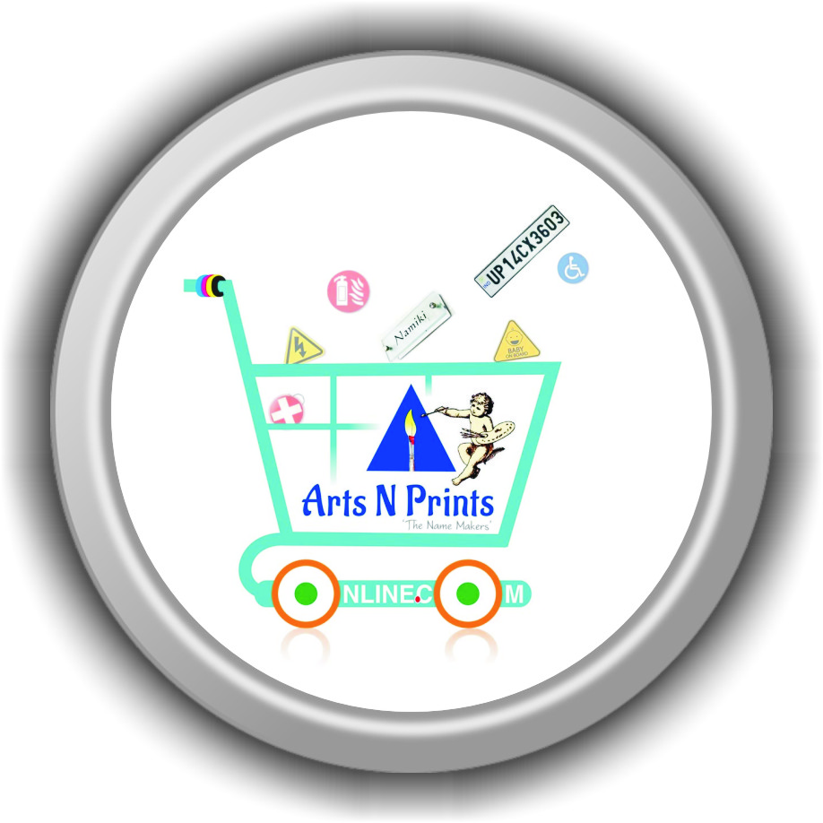

JOB INFORMATION

Department : Sales, Services & Promotion
Role : Relationship Officer (Full Time)
Login : 9:15 am
Log Out : 7:30 pm
Report to : Sales Team Head (email-CC) to HRA and (email-BCC) to Manager
Working Days : 25 days
Leaves : Paid 12 holidays in a year
Salary : Fixed + Incentives on performance, achievement, fulfillment, PF, ESI
Payment : Monthly
Bonus : 25,000.00* T&C
Training : Learn | Train | Manage | Upgrade (1 week Schedule)
HR Department | Sales Department | Promotions | Company |
(Industry, 8 Domains, Category, Sub category, Process, Raw Materials, Machines, Customers, Reporting, Communication and many more essentials.
Meetings : Weekly, Monthly, Quarterly
Discussion : Daily
Reports : Daily, Weekly, Monthly, Quarterly and Yearly

JOB INFORMATION
Relationship Officers handle the concerns of the people who buy their company's products or services. They work to rectify issues experienced by individual customers as well as aim to improve the organization's overall customer satisfaction ratings.
Relationship Officer is a person who loves interacting with people, a streak for experimentation and great social skills. Leads a team of Front officer executives to achieve specified sales targets. Has to be involved in promotion, marketing and PR activities. Provide the team with a vision of the companies objectives. A relationship manager is a part of the sales team who builds and maintains relationships with clients and customers. Some relationship managers work only with clients, working to solve any business or technical challenges that they face. They will help them with sales opportunities and drawing in customers.
An employee who works at various branches, tasks, times, or locations, as required by an company. Being a Sales department Relationship Officer, required to be knowledgeable of all duty & jobs within the department and should able to fill in or “float” from one branch to the next when and if need. Under indirect supervision of the project manager and team head, will provide support in various sales and booking custom orders based on daily sales needs. By performing the following duties in either the booking custom orders, promotions etc…
Attracts potential customers by answering product and service questions; suggesting information about other products and services. Accept customer Customized orders or product booking by recording or written information. Maintains customer records by updating purchase information.
Responsible for handling front office reception and administration duties, including greeting guests and offering them a beverage, answering phones, handling company inquiries, and sorting and distributing mail. Mail also schedule meetings and travel for team head and managers.

JOB SPECIFICATIONS:
Relationship Officer are the principal point of contact between a business and its customers. Relationship Officer ensures current customers have the right products and services, identify new markets and customer leads, and pitch prospective customers. In many ways the face of the company, Relationship Officer may do everything from answering phones to monitoring the competition, all while maintaining good customer relations and pursuing new sales opportunities.

SKILLS REQUIRED:
The skills required for this job the most are Oral / Verbal and Written Communication and Results Driven Office Administration, Persistence, Customer Service, Selling to Customer Needs, Meeting Product Knowledge, Time Management, Closing skills, Quality Focus, Territory Management, Problem Solving, Market Knowledge, Prospecting Skills, Documentation Skills, Listening, Phone Skills & Sales, Negotiation, Sales Goals, Handles Rejection, Resolving Conflict, Posting Ads, Analyzing Information, Self-confidence, Presentation skills, Client Relationships, Motivation for sales, Professionalism and Multi-tasking, Training & Monitoring HTCS, Front Office Executive in daily task, achieve targets, and generating various reports.

Job Information
1. Job Title : Relationship Officer Sales
2. Pay Grade : Fixed Salary + Incentives
3. Reporting Person : Sales Team Head | BDE | Manager
4. Shift Timing : 9.30 to 7.30
5. Department Name : Sales, Service & Promotion
6. Location : Across Bangalore

Sales Lead Conversions | Business Growth | Customer Retention

Job Summary
1. Job Purpose : For Customer Service under Development & Expansion Plan,
2. Job Importance : Sales play a key role in the building of loyalty and trust between customer and business as well training and monitoring HTCS across Bangalore. ... During sales interactions, encouraging the customer to recommend a friend or give positive feedback can have an impact on the growth of the business through increased brand awareness and sales. The Operational and Sales, Relationship Officer is responsible for supporting the efficient operation of the branches HTCS by working in three primary areas:
3. Job Significance : The term refers to the perception that one's job or task exerts a positive impact on others. It is commonly perceived as meaning fullness of one's work. You will be responsible to get business to fulfill the demand of production team daily.
4. Job Value : Your work values are the subset of your beliefs and ideas that are related to your occupation or job. These core principles are an important part of who you are. They include things like honesty, service, self-respect, respect for others, peace, and success.
5. Contribution : The contribution sales ratio is the contribution to the revenue of the company that each sale of a product has. ... The contribution sales ratio is calculated by subtracting variable cost of sales from the sales revenue and dividing that number by the sales revenue.

Job Challenges
1. Deadline : It's a powerful word that strongly suggests we must meet the time limit that's been set, otherwise we're dead if we miss it. The ironic thing is that nothing provides more focus on our priorities and time management skills better than setting a deadline. We are usually at our best when we are racing to meet the timeline that’s been set because we are determined and focused on completing the assignment or project at hand.
2. Punctuality : Punctuality is a sign of professionalism and helps you stand out as a reliable and trustworthy employee. If you don't get your part of a project completed on time, you keep others from being able to finish their tasks. Being punctual helps you establish your reputation as a dependable and consistent worker.
3. Quality : In our business, of Print on Demand custom product manufacturing, quality has a pragmatic interpretation as the non-inferiority or superiority of something; it's also defined as being suitable for its intended purpose while satisfying customer expectations.
4. Accuracy : In measurement of a set, accuracy refers to closeness of the measurements to a specific value, while precision refers to the closeness of the measurements to each other. In our Business Demand on Printing and Signage 0% error is accepted.

Working Conditions

1. Education : Graduate | UG
2. Experience : Sales or Marketing 0-2 years
3. Overall Qualification
4. Skills : Internet Savvy, Basic Computer, Calcus
5. Knowledge : Languages
6. Expertise : Convincing

Working Hours

1. Start Time : 9.15
2. Finish Time : 7.45
3. Working Hours : 9 Hours. (100hrs)
4. Tea Break : 11 & 5
5. Travel Hours : Nearby HTCS
6. Location : Across Bangalore

Job Responsibility:
Our company is looking for a Front Office Sales Executive to be responsible for generating leads and meeting sales goals. Duties will include sales presentations and product demonstrations, as well as negotiating contracts with potential clients.
In order to be successful in this role, you will need to have a deep understanding of the sales process and dynamics, and also superb interpersonal skills. Previous experience in a sales role is an advantage.
Front Office Sales Executives present and sell products or services to B2B and B2C, organizations, businesses or government agencies. They contact potential buyers, present products and services, answer questions and discuss pricing.
- Generating leads by posting ads in social media and registration in different business portals.
- Meeting or exceeding sales goals.
- Negotiating all contracts with prospective clients.
- Helping determine pricing schedules for quotes, promotions, and negotiations.
- Preparing weekly and monthly reports.
- Giving sales presentations to a range of prospective clients.
- Coordinating sales efforts with marketing programs.
- Understanding and promoting company sales programs.
- Obtaining deposits of payment from clients.
- Preparing and submitting sales contracts for orders.
- Visiting clients and potential clients to evaluate needs or promote products and services.
- Maintaining client records.
- Answering client questions about credit terms, products, prices and availability.


Setting a standard across the sales team is imperative, and this is done by establishing goals via sales quotas. Quotas allow managers and executive to know what it takes to be successful. But there’s an art to setting proper sales quotas. If they’re too hard or easy to achieve, it’ll kill motivation. Executive either give up due to feeling defeated, or they’ll take their foot off that gas and glide into their sales quota with minimal effort.
Done properly, Executive will know what it takes to thrive and stay motivated until they achieve the (realistic) goals set forth.

Why Goals Are The Backbone of Sales Success
– Holds everyone accountable
– Drives motivation
– Boosts sales
– Clear and concise way to measure success

We know how to set goals but often fail to recognize and understand how to actually achieve the goals we create for ourselves. Enter S.M.A.R.T. Goals – the best method to not only set goals, but make sure there’s a plan in place to reach our desired result. And we have set an achievable Goal.

Big Goals Invite Big Obstacles
It’s no secret that accountability produces results. Whether a manager setting the quota for our team or a sales executive who won’t stop working 15 hours a day to get that beautiful new iPhone that’s been on his mind, holding yourself accountable is the driving force that allows you to reach beyond your current disposition and realize your maximum potential.

To say that you’re going to encounter a few bumps in the road along the way is an understatement. Whether you’re setting sales goals or personal goals, the path to success is not void of obstacles.
The people who push on and persevere when everyone else so eagerly gives up are the people with the biggest goals. When you have small goals, every challenge proves more difficult and every obstacle seems larger.
Top Goals

Activity Goals
Or better known as, “sales activities”, are goals that measure activities of each executive. Activity goals are 100% controlled by the executives. It’s up to the individual to hit these metrics; which is can usually accomplish through effort and focus. Achieving activity goals sets them on track to hit their daily, weekly, monthly, and annual goal.
Examples of activity goals: doors knocked in a day, appointments set per week, proposals sent, etc.

Annual Goals
Your annual goal is the driver of all your goals. Hitting these targets is – ultimately – the most important. However, this is a number, target, metric, and/or measurement that management/executives focus on; it’s too overarching for executives to concern themselves with.
An example of an annual goal would be: Increase new accounts by 15%.

Team Goals
A team goal is usually measured on a monthly or quarterly basis and requires each team member to contribute a certain percentage in order for the team to be successful. The real purpose behind a team goal (because individual goals suffice to reaching the annual goal just as well) is to provide unity amongst the team. When everyone works together to share in a common goal, it build camaraderie and drives a motivated sales culture.
An example: sell a combined total of at least 24,000,000 in FY this quarter.

S.M.A.R.T. Goals Stands For:
Specific clear and unambiguous telling exactly what is expected
Measurable concrete criteria for measuring progress toward goal attainment
Attainable challenging and high reaching but ultimately can be achieved
Relevant is in alignment with the individual, team and goal
Time Related a committed deadline

SMART Goals Examples
SPECIFIC: More than just setting a goal to increase door knocks, a SMART goal would be to increase door knocks by 10 per day.
MEASURABLE: Have a concrete number to achieve. For example, increase sales by 17% by the end of the next quarter.
ATTAINABLE: Don’t set a goal that is not possible to reach. For example, increase door knocks by 10 per day is doable. Increasing by 500 is just unrealistic.
RELEVANT: If it doesn’t fit with the mission of the company as a whole, you may want to find a new goal to set.
TIMELY: There needs to be a due date on the objective. Increasing door knocks by ‘X’ amount by ‘X’ date is how you set a SMART sales goal.

Setting goals is crucial to success. Why? Because they hold you accountable, keep you motivated, and give you a way to measure success. There are some specific guidelines when setting goals to adhere to in order to make them attainable. By following the SMART guidelines we’ll create goals for our team or ourself that will increase the likelihood of you hitting them, which is the ultimate goal, right?
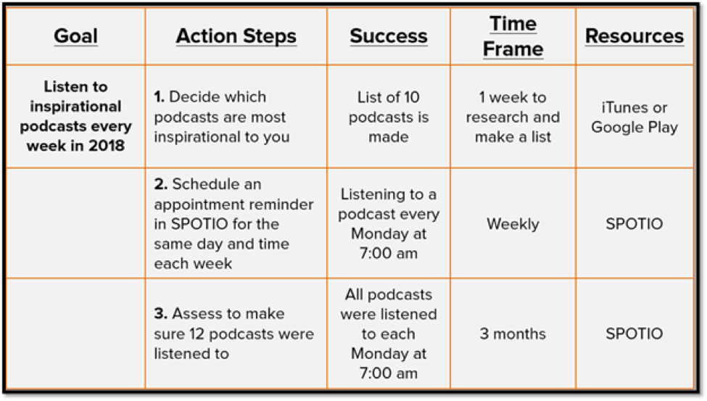
As a sales professional your goals are likely income related. Whatever your number is, you can achieve more by clearly defining it. The last thing you want to do is wait until September to realize you’ve earned goal. This would make it astronomically more difficult to achieve, so you need to be more specific.
For the executives selling a product with a short sales cycle, where the decision from a prospect is almost immediate in terms of whether they’re going to buy or not, break your larger goal down into smaller, more specific weekly goals. 1.2 cr per year is roughly 3 lakh per week, so this would be a good weekly income target.

Goal #1 | 1,000 per Week in Commission
Goal Type : Individual Weekly
Strategy : Touch base with lost deals, prospect larger accounts, or upsell current clients.

Goal #2 | Double Your Number of Visits
Goal Type : Individual Quarterly
Strategy : This is pure grit. Get out there and prospect in between meetings. Before you take a break to check social media, hit up one more business. Just adding in one more action each day will result in big dividends.

Goal #3 | Close 4 More Deals Next Month
Goal Type : Individual Daily/Weekly
Strategy : Not unlike the strategy for Goal #2… work it!

Goal #4 | Increase ASP (average sales price) by 20000 Next Quarter
Goal Type : Team Goal
Strategy : Working together this can be achieved. Run promo’s and really sell the value of our offering during each meeting by proving how you can solve their pain.
By focusing on these two areas you’re going to force yourself, or our team, to take the necessary steps to reach your sales goals. Creating a goal for sales attempts provides insight into your pipeline.
The number of attempts you or your team makes each week is great to track and measure because it’s a controllable. It’s also exceptionally beneficial if you understand how important your sales process is, specifically as it relates to follow ups. One of the biggest mistakes salespeople make is not following up, regardless of the reason.
The truth is that your sales fortune is in the follow up because 48% of salespeople won’t even make a single follow up attempt. With 80% of sales requiring at least 5 follow ups after the initial meeting, you’re losing out on an absurdly ridiculous number of deals by not reaching back out.
The income goal will have you focused on pushing potential customers through the pipeline quicker, having leads come out the other end as sales and income. Don’t put too much emphasis on one over the other because:

Greater Emphasis On Income = Not filling up your pipeline
Greater Emphasis On Attempts = Not driving your pipeline

Monitor KPI’s with a Sales Activity Track Records
To validate, monitor and achieve sales goals, you need to understand what is takes in order to achieve them. KPI’s are your eyes and ears to ensure you’re reaching targets.
Utilizing an activity track record that’s tied into your sales record book is a great way to coach our team and show executives the activities they need to accomplish in order to be successful.
However, any time a executive hears the word “tracking”, they automatically assume you’re “big brothering” them.
This is not always the case.
Tracking your desired KPI’s through activity track record book shows you the volume of each activity (contact attempts, pipeline velocity, opportunities, etc.) that needs to be attained in order to reach goals.
It’s not micro management; it’s providing actionable insight so executive can exceed their quota.
Result for Executives: more closes. Results for Managers: growth in revenue.

Using SMART Goals as a Sales Manager
A great exercise is to sit down with your team at the beginning of the year to walk them through this exercise. They might not even know their goals. Help them create their goals, track them and hold them accountable.
There’s no better way to have a happy sales team than when they are crushing their goals.
The accountability starts now!

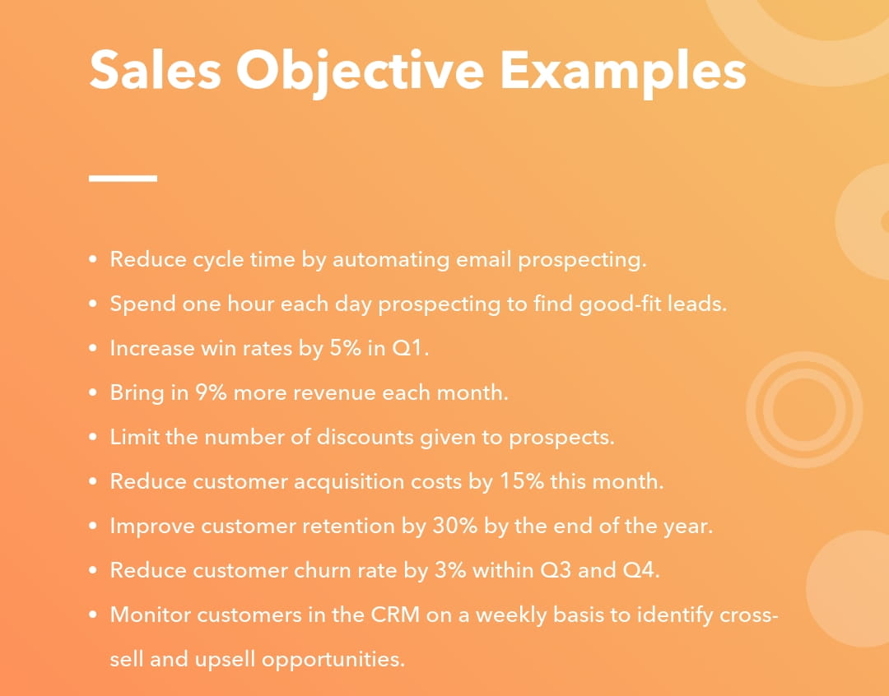

Types of Sales Objectives
A business' sale objectives often fall within one of the following categories, but objectives can vary from Time to time.
- Cycle time
- Leads
- Win rate
- Revenue
- Profit margins
- Customer acquisition costs
- Customer retention
- Churn rate
- Cross-sell and upsell

Capability Index
The Sales Capability Index (SCI) is an index , which provides a capabilities score that, for the first time in the industry, provides a holistic, quantified assessment of FOES and team readiness while also producing a leading indicator of their expected performance.
Competency Framework | Sales Competence Model
Sales competencies defined in terms of knowledge, skills, habits, and motivators
Here you can use our sales competence model as a base for your own. You can learn how we define a sales competency and find information about using it to drive learning.

The Nineteen Sales Competence Factors
1. Answering Common Customer Questions - Expertise, knowledge of value and proof points, skills
There are six common questions that buyers have in mind when considering new purchases or suppliers. Those who have good answers increase credibility, reduce anxiety, and develop trust more easily.
2. Market and Industry Understanding - Expertise and knowledge
Salespeople, who have expert knowledge of the market and industry that they operate in, find it easier to build important contacts and recognize worthwhile opportunities. It helps them establish credibility, communicate value, and develop trust.
3. Customer and Prospect Understanding - Expertise and knowledge
Ability to persuade depends on understanding. Knowing how a customer’s business works helps salespeople position the value they offer and acquire trusted advisor status.
4. Company Understanding - Knowledge
Those who know their company's goals, objectives, strategy, needs, strengths, and weaknesses understand the capabilities and resources available to address the market.
5. Written Communication - Skills
In addition to general customer communications via letter and email, many salespeople must prepare their own quotations and proposals. The increasingly important personal marketing and digital selling techniques rely heavily on writing skills.

6. Understanding and Articulation of Value - Expertise, knowledge, and skills
Complete understanding of the value provided by the products or services represented is an aspect of a salesperson's knowledge that shouldn't be taken for granted. Equally important is ability to communicate the value effectively. Aspects 1 through 6 of the competency model are explored and evaluated in the Sales knowledge Assessment.
7. Proactive Prospecting - Motivation, planning, methods, and skills
If marketing activities don’t generate enough leads and enquiries, salespeople must be able to find their own. Effective and efficient prospecting can make all the difference when business is hard to come by.
8. Networking for New Opportunities - Motivation, planning, methods, and skills
Networking is an alternative means of finding new prospects. It depends on having a favorable relationship with a wide range of business contacts in the industry and related industries.
9. Opportunity Qualification - Planning, methods, tools, habits, and discipline
Doing things right is a waste of time if people don’t first choose the right things to do. Qualification has a substantial impact on success.

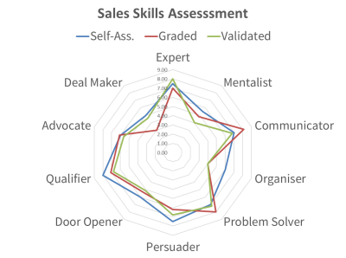

10. Forecast Accuracy - Planning, methods, tools, habits, and discipline
Apart from an accurate forecast being essential for good business management, is also helps salespeople secure the right resources to win the business opportunities addressed.

11. Organization and Time Management - Planning, methods, tools, habits, and discipline
Forethought, planning, and preparation precede success. Making good use of the time available and paying attention to detail are also important sales competencies.

12. Managing the Sales Process - Planning, methods, tools, habits, and discipline
Using a system or method that has proved effective elsewhere provides a benchmark for measuring progress and a common language for communicating internally. Frameworks and checklists help sellers avoid mistakes and develop better methods.

13. Interpersonal Communication - Empathy, sensory acuity, knowledge, experience, and skills
Good communication is a foundation stone of success. Many aspects of sales competency depend on the salesperson’s ability to discover information that isn't publicly available, shift another person's perspective, and make a convincing presentation.

14. Handling Objections - Preparation, methods, and skills
Buying objections thrown up by customers can delay or stall business that otherwise could be concluded. Salespeople need ability to turn objections around.

15. Progressing a Sale - Preparation, methods, and skills
Moving a sale forward depends on ability to influence customer staff manage the customer's buying process. Salespeople need to gain agreement and motivating action at all stages of a sale.

16. Negotiating Terms - Preparation, methods, and skills
Some elements of negotiation are important throughout a sale however the final negotiation often brings out different behaviours, tactics, and ploys. Salespeople need formal negotiation abilities. Sales competencies 6 through 16 of this sales competence model are explored and evaluated in our Sales assessment.

17. Self-Development - Planning and discipline
In a competitive market, organizations must continuously increase productivity. Salespeople must keep getting better. Otherwise their company will inevitable be overtaken by competitors.

18. Sales Mindset - Beliefs, values, virtues, motivation, and attitudes
Attitude dictates thinking and thinking dictates speech and actions. There are attitudes that help salespeople succeed and there are those that hinder. While attitude itself cannot be a competency, having attitudes compatible with success, can be considered an aspect of sales competence. Beliefs about selling and attitudes towards sales challenges and self-development are reflected and investigated in the Sales Mindset assessment.

19. Sales Motivators
Motivation has a major impact on the decisions salespeople take and the actions that follow. Consequently, a salesperson's intrinsic motivators, have a bearing on success which differs according to the role being fulfilled

Criticality and Capability Matrix
The Capability Matrix forms part of the overarching Performance Expectations Framework for Professional Staff and describes the functional capabilities required to perform effectively as a higher education professional.
A maintenance criticality matrix, or risk matrix, is a tool that helps companies and plants assess the criticality of a given risk. Structures often use it when they want to manage, anticipate and annihilate potential failures.

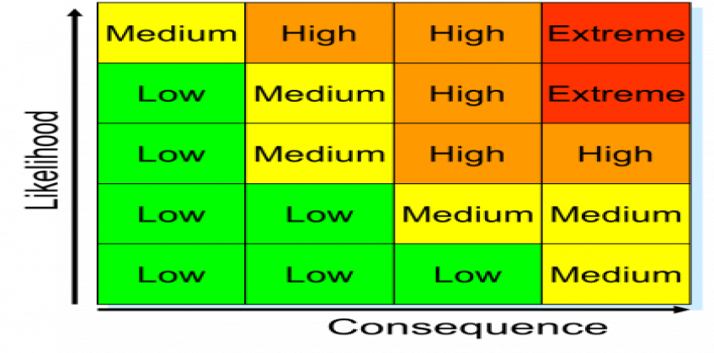

What is a criticality matrix?
Criticality matrix allows you to quickly analyze the most critical equipment of your machine pool during a given period. They are made to ease the analysis thanks to a color code: yellow for minor elements, orange for less important ones and finally red for the most critical ones. To make the best use of it, one needs to take the different parameters into consideration (cost center, maintenance technician, tag, equipment…), that can be selected, as well as variables (intervention time, number of interventions). All the data displayed come from your computerized maintenance management system software Mobility Work, and are gradually fed by maintenance technicians’ interventions. It is possible to filter information to obtain a level of criticality according to the defined filters:
- equipment
- cost center
- tag
- tasks creator
- task status
- maintenance plan choice
- intervention length

Potential and Performance Matrix
How do we evaluate a sales executive performance?
5 ways we evaluate sales executive more fairly and effectively and look at the whole picture of what they bring to our team:
- Measure process, not just final results. ...
- Promote good prospectors. ...
- Reward training. ...
- Recognize teamwork. ...
- Think about the next deal.
...Being a sales professional is often very stressful, as there are high demands to meet sales quotas. After all, if salespeople don’t make their numbers, it not only impacts their goals, but the financial needs of the companies. Because of this, there is tremendous pressure placed on hitting their sales.
But even though sales numbers are hugely important, they’re not the only way to evaluate the success of your sales team. If you’re trying to identify which salespeople on your team are the top performers and which ones might need to make a career change, it’s important to know how to look beyond the immediate numbers and develop a more nuanced way to evaluate sales reps’ performance.
Final sales numbers are often the most attention-getting stats for sales managers, but there are a lot of other elements that go into creating those final numbers.

Here are 5 ways a company evaluate sales executive more fairly and effectively and look at the whole picture of what they bring to team:

1. Measure process, not just final results
It might sound counterintuitive in such a results-driven business, but more sales teams need to focus on the overall sales process, and not just the final results. You need to have a “sales funnel” in place that guides your prospective customers through each stage of the buyer’s decision-making along the entire customer journey, including these touch points:
The first contact or initial inbound inquiry
The earliest discussion to assess the customer’s needs
More detailed relationship-building conversations and discussions about the potential ROI of the customer buying your solution
The final sales closing
You should evaluate your reps not only on how well they close deals, but on how well they work through each stage of the sales process. You might discover that some of your best closers struggles with the early stages of making a sale, and that some of your salespeople with lower conversion rates in the final stages are great at qualifying sales leads initially.
Measuring the overall performance of your reps throughout the sales process will help you identify people’s individual strengths and help your sales team get better as a whole. Unfortunately, many sales teams currently do not have a consistent sales process in place–according to stats cited by Hub Spot, 68% of B2B organizations have not identified their sales funnel.

2. Promote good prospectors
Most salespeople hate prospecting. They hate making cold calls, and they hate making those first uncertain steps on the road toward finally closing a sale. This reluctance means that there is an opportunity to find the salespeople who actually enjoy prospecting and who are good at it, and make prospecting a niche role within your sales team.
Perhaps you’ve got salespeople who struggle with closing sales or building longer-term relationships, but who have the right energy level and relentless ability to keep getting on the phone and introducing themselves to new prospects. Find a way to reward your salespeople who do the parts of the job that most salespeople don’t want to do.

3. Reward training
Many sales managers believe in the 80-20 rule—the idea that 80% of your sales results come from the top 20% of your sales reps. If this 80-20 rule is true for your organization, it can be tempting to just let your top sales reps keep doing their own thing and keep selling and selling—but this can be a mistake. Instead of evaluating your top sales reps based only on their sales numbers, try to capitalize further on their success by asking them to create best practices and training opportunities that can be shared with the rest of the team.
The best players in sports don’t just rack up great statistics for themselves; they find a way to make other people on the team get better. It’s the same for sales. Enlist the support of your best salespeople in training the rest of the team. Find out what they do so well, and replicate that success—and make sure your top sales people understand that training is part of their job performance evaluation.

4. Recognize teamwork
Is our sales team truly a “team” or just an assortment of individuals? Good sales teams should have a spirit of friendly competition, but everyone needs to understand that the real competition is outside the organization. They’re ultimately not competing against each other—they’re helping each other compete against your company’s competitors. Look for ways to reward sales reps that exhibit and promote good teamwork, whether that means filling in for someone on a client meeting, or helping a teammate close a big deal.

5. Think about the next deal
We talk a lot about building relationships with potential customers, but what does it really mean? Making a sale is huge, but what about when it comes time to renew or upgrade? And are your customers likely to refer you to someone else?
Another important part of the sale is how your customer feels about it afterward. Aggressive salespeople who will do anything to close the deal can be a huge asset to your team, but if they over promise or disappear after the sale, it can leave customers unsatisfied. Tracking and monitoring your progress by repeating customer satisfaction ratings six or 12 months after the sale can be another great way to tell whether your team is building successful long-term relationships—or just padding short term numbers.

- Meeting with potential clients to gauge the utility and viability of prospective working relationships.
- RO should ensure alignment between our organization’s objectives and each client’s needs.
- Ensuring regular contact with existing clients to maintain our company's presence.
- RO has to be in contact with existing clients to make them aware of the products and services provided by the company on a regular basis.
- Repairing disengaged or fractured relationships.
- Conducting in-depth needs assessments to better understand each client's requirements.
- RO has to keenly listen and understand the requirement of the customer to suggest the best possible services to the customers.
- Identifying a range of our offerings that could meet the goals and values of each client.
- RO has to gauge properly the customer requirement and suggest them the best suitable products and services.
- Proposing and deliberating potential solutions in consultation with clients.
- The RO must be well equipped with product and service knowledge to make decision on providing the best services to the client.
- Harnessing internal relationships to better address clients' needs and to maximize our profits.
- Always work on improving the internal relationships between the various teams to improvise the company profits.
- Collect client feedback about their experience.
- After ensuring the product is been delivered to the customer is proper manner send the feedback from to collect the reviews from the customer based on the service provided through Google sheets.
- Develop relationships with clients and key personnel (FOES).
- Work on maintaining a better relationship between the internal and external team.
- Overseeing the relationship with customers handled by your team.
- Must monitor the performance of the FOEs working at various locations.
- Resolving customer complaints quickly and efficiently.
- FOE has to constantly follow up with the required departments to resolve the issues by the customer and ensure that it is been solved at the earliest.

- Keeping customers updated on the latest products in order to increase sales.
- FOE has to be in contact with the existing customers and keep updating them with the latest products or services of the company.
- Meeting with managers in the organization to plan strategically.
- RO has to report to the managers once in a week and discuss about the business strategies and business plans.
- Expanding the customer base by up-selling and cross-selling.
- Attempt to sell additional merchandise or services to prospective or current customers by telephone or through visits.
- Understanding key customer individual needs and addressing these.
- RO has to understand the customer requirement and suggest the best solutions.
- Knowing your competition and strategizing accordingly.
- Ro must be well trained to understand the competition and work on the strategic plans.
- Maintaining a deep knowledge of company products and services.
- Ro has to update his knowledge regularly on the company products and services.
- Researching and pursuing new business opportunities.
- Ro has to work on the plans to increase the business opportunities.
- Meeting sales/revenue targets.
- RO has to work aggressively towards the given targets and work towards the achieving them in the provided deadline.
20. Conducting physical visit and facilitating the movement of front office executive sales through our High Touch Stores across city.
- RO will be visiting the locations under his control to supervise the work carried out by FOEs regularly.
21. Training FOES the product knowledge, digital payments training from POS devices, performing targets, promotion of HTS location in internet and maintaining an report of branch business.
- RO has to train the FOEs thoroughly on the company products and services.
22. Visiting customer sites for booking custom orders, with in a 1km nearby branches or on the way to HTS, as per schedule or on overnight assignments.
- RO will be visiting the client place based on the requirement to take the orders.

Promotion Responsibilities
- Supporting the Marketing Manager and marketing team with project organization.
- Work with the Marketing team to work on the plans to improve the business.
- Employing online marketing analytics to gather information from web and social media pages.
- Adopting the social media strategies to carry out new business strategies.
- Updating databases, spreadsheets, and inventory lists.
- Updating the databases and records periodically.
- Preparing promotional presentations and organizing promotional events.
- Organizing the promotional events which prove to be increasing the sales of the company services.
- Posting online content for the company’s social media page and website.
- Carrying out promotion activities in social media as directed by the SEO team.
- Evaluating brands' target customers to identify the social media channels that would provide the best opportunities for customer engagement.
- RO must be equipped with knowledge to identify the potential customers who can be reached through the digital media.
- Evaluating clients' marketing budgets and allocating spending on various marketing needs accordingly.
- RO has to understand the client budget and suggest them the services accordingly.
- Identifying new opportunities to encourage customer engagement.
- Identify new opportunities to carry out customer engagement.

Job Duties and Tasks for Relationship Officer sales “LMT”
LEARN | TRAIN | MANAGE |
1) Influences customers to buy Product, services and merchandise by following a prepared sales talk to give service and product information and price quotations.
2) Obtain customers’ names, addresses, and billing information, product numbers, and specifications of items to be purchased, and enter this information on order forms.
3) Prepare invoices, shipping documents, and contracts.
4) Inform customers by mail or telephone of order information, such as unit prices, shipping dates, and any anticipated delays.
5) Receive and respond to customer complaints.
6) Verify customer and order information for correctness, checking it against previously obtained information as necessary.
7) Direct specified departments or units to prepare and ship orders to designated locations.
8) Check inventory records to determine availability of requested merchandise.
9) Review orders for completeness according to reporting procedures and forward incomplete orders for further processing.
10) Attempt to sell additional merchandise or services to prospective or current customers by telephone or through visits.

11) File copies of orders received, or post orders on records.
12) Compute total charges for merchandise or services and shipping charges
13) Confer with production, sales, shipping, warehouse, or common carrier personnel in order to expedite or trace shipments.
14) Recommend merchandise or services that will meet customers’ needs.
15) Adjust inventory records to reflect product movement.
16) Collect payment for merchandise, record transactions, and send items such as checks or money orders for further processing.
17) Inspect outgoing work for compliance with customers’ specifications.
18) Notify departments when supplies of specific items are low, or when orders would deplete available supplies.
19) Recommend type of packing or labeling needed on order.
20) Calculate and compile order-related statistics, and prepare reports for management.
21) Maintains operations by following policies and procedures; reporting needed changes.
22) Contributes to team effort by accomplishing related results as needed.

You have to improve your sales and learning skills and maximize your potential

1. Product Knowledge
A Relationship Officer who doesn’t perfectly understand the product we’re selling is a completely ineffective exe. Product training should be one of the very first things you should learn – you should be able to explain in detail how each product works, what business value it offers, and the reasons it appeals to our company’s ideal customers. You will help FOEs (Front Office Exe.) craft sales pitch effectively, and ensure you highlight each product’s strongest features. Deep product knowledge is honestly one of the few things that separates the top 1% of executive from the rest.

2. Strategic Prospecting Skills
Once you have the product knowledge to sell, it’s time to do some prospecting. However, while many sales leaders have their quota-carrying executive also do early cold-calling, We actually don’t suggest for FSE to do cold calling. From a unit-economics perspective, it is obviously considerably more cost-effective to have our Relationship Officer (ROs) do cold calls, while our quota-carrying ISEs should be doing more sophisticated prospecting – what we call “strategic prospecting”. This means searching for referrals through existing connections to new prospects that fit the target buyer or ideal customer profile. It’s also important for executive to go back to Closed-Lost opportunities with whom they already had previous conversations and try to revive them. Another strategic prospecting activity is to ask for referrals from existing customers, and even talk friends and family for referrals to their portfolio companies. All of this is fair game for the quota-carrying FSEs to do prospecting.

3. Rapport Building on the meeting
FSE’s have a advantage over outside sales in that they’re meeting with prospects face-to-face. This means they have to work harder to build a connection with busy and sometimes hostile strangers in our HTCS. Some sales executive already have a natural ability to create an instant rapport with a prospect, and only have to finesse it. Other Executive can learn to research prospects in advance and find common ground to empathize with the person on the other end of the line. Whether you’re chatting about sports, attending the same college, or just the weather, rapport should not be underestimated.

4. Buyer-Seller Agreement
In order to set mutual expectations and to make your prospects more comfortable, sales executive should learn how to create a Buyer-Seller Agreement, to set the tone for all calls and meetings. These are verbal agreements at the beginning of the sales process that outline expectations for both sides. For example, a sales executive can ask a prospect, “Is it OK to ask a few questions about your requirements and then I will show you a demo of our product to see if there is a potential fit for both of us?” It allows the prospect to feel comfortable and understand what is coming next, so no one feels ambushed by the next step. It also allows the sales executive to open up a two-way street in the selling process so that both parties get to a win-win conclusion.

5. Active Listening
Most sales executive feel comfortable talking to prospects, but listening is another story. FSEs need to become proficient in active listening, or listening with a strict focus and asking intelligent follow-up questions. People can usually tell if you’re really listening to them, rather than just thinking about what you’ll say next – and most people appreciate a good listener. Great listening skills can help reps empathize with prospects to learn more about their business and pain points. With that knowledge, they can then sell more effectively and offer a better solution.

6. Communication
The tone of voice, volume and pace of a sales executive’s speech are surprisingly important sales skills. In sales, how you say things to a prospect matters more than what you say. According to Sales Training, only 7% of communication relies on the content of what you say, whereas 38% of communication is about other attributes of communication such as tonality, etc. As you may have heard before, it’s not what you say but how you say it. executives should try to subtly mirror a prospect’s tone of voice and style of talking – if a prospect is more formal and polite, speak similarly; if they’re more informal and joke around, do the same. This helps prospects feel familiar with you, and relate to you more easily to create rapport. Executives also need to speak clearly, not too quietly, and not in a monotone. You need to let your emotion and personality shine through, so that the person in the HTS knows you’re a human, and is interested in talking to you.

7. Qualification Questioning
FSEs need to start off every sales conversation by asking questions during the Discovery phase to analyze a prospect’s business needs (i.e. Needs Analysis). It’s important to not just throw random features and benefits at the prospect hoping something will stick. In fact, I tell FSEs to stop sharing all of our product’s capabilities all at once. This is a bad tactic. Instead, you need to delve deep to discover your prospect’s business pain and how our product can help them solve it by asking qualifying questions. These questions help you determine what you should share about the benefits and value in our product based on what is going to be most important for them. Beyond the Discovery stage of the selling process, over time, FSEs will need to qualify prospects for Budget, Authority, Need, Timeline, Competition and Buying Process in order to get all the key criteria that will help them get to the purchase. Being good at qualification is critical to be a successful Front Office Sales Executive.

8. Time Management
The most effective FSEs are able to make the most of their time, with more dials and more connects than other Executive. The key to being highly productive is using good time management skills. We will train each rep to sort through leads to find the most promising ones, and not waste too much time on a deal that isn’t going anywhere. You can use analytics to identify the industry, business size, and other characteristics of ideal leads, and share the information with our team. It’s vital to make the most of the hours in the day to bring in more deals per executives.

9. Objection Prevention
Great sales executives practice the art of proactive “Objection Prevention” and not merely “Objection Handling” and can thus reduce some of the most basic objections by way of how they approach a sale. We train our reps to be strategic and think ahead by studying what typical objections come up in most cases. For example, there is no reason to get to a point when a prospect can say, “I don’t have a need for this” or “Call me again in a few months”.
It is possible to be proactive and address a common objection before it even comes up. For example, at Newtech, many of our executives hear people say “You do Signs for office or houses but I can get done from local anyway.” Instead, we preempt that objection.

by sharing during our Discovery Call that our cross-object sales reports are impossible to run in the CRM and yet these reports can save time for the Sales VP or CEO to run and can help grow revenue significantly and all this is possible in a few clicks of a mouse button instead of days spent in Excel with data that will be antiquated by the time you’re done.

10. Objection Handling
Even the best executive can’t prevent every objection, so it’s important to help our team prepare for objection handling when they do hear one. executive have to be on their toes so that the sales process doesn’t end abruptly and they lose the opportunity at the deal. On our sales team at Newtech, we coach executives to empathize, soften and ask good questions to understand what is genuinely at the core of what the prospect is concerned about. Executive need to learn to sincerely understand the prospect’s problem, ask for more information, and offer clarity to help the prospect overcome their objections. we do extensive role play and training to help prepare our team for this.

11. Demo skills
For many Print on Demand products B2B and B2C the demo is critical to starting a sales process. Sales Executives need to not only understand the product, but must be able to show off it’s capabilities to a prospect effectively through a demo. Demos are challenging in that executives need to first discover what benefits will be most important to solving a prospect’s pain, and highlight the business value of those features during the demo. Throwing too many features at the prospect is a bad tactic and can overwhelm and confuse them. This is another skill that you should practice, so you can practice our demo presentation, and clearly be able to show off the product.

12. Gaining Commitment
Great FOES can get a prospect to commit to a deal fairly quickly. The key is making sure the right people with the right approval power are bought in to the process as the sale progresses. Executive must continually ask questions, assess the prospect’s needs and reinforce what the prospect is interested in buying. FSEs should ask “Is this helpful? Is this how you envision it?” and more. By forcing the a prospect with buying power to acknowledge again and again that you’re offering them real value, it helps push them to commit to a deal.

13. Closing Techniques
Now that the FSEs has convinced the prospect that their company or individuals needs the product, it’s time to close. Our Managers will train executives to push prospects, ask for the order and get it signed fast. A lot of prospects will try to push the closing date back a few weeks or a few months, and our executive may be trying to reach a monthly or quarterly goal for the team. In this case, FSEs have to establish a timeline, and push the prospect to sign using a compelling event. This shows how the prospect is missing out on revenue by not having the product in place now. With the right combination of pressure and value offered, FSEs can learn to close deals sooner.

14. Post-Sale Relationship Management
Many of us forget to thank customers and to continue building and maintaining the relationship after the sale. Firstly, it’s important to be appreciative for the business regardless of whether the customer will buy from you again. This is just common sense and common courtesy. And those sales executive who are genuinely appreciative are the ones who typically grow professionally and become masters of their craft. Furthermore, you don’t want our customers churning later and going to a competitor. Additionally, our customers can and will refer you to other customers. Finally, even ten years later you can still go back to the individual to whom you sold years ago and they may still become a customer even when both of you are in a new and different company. Relationships really matter; it’s that simple. Yet some executives don’t engage in post-sale with their customers. This is a key area at which I encourage all FSEs to get really disciplined.

Relationship Officer
In any organization, the sales department plays a pivotal role in the success of the business. The unique and important role of sales is to bridge the gap between the potential customer’s needs and the Products/services that the organization offers that can fulfill their needs. Here are some of the key ways in which sales impact the organization’s success:

Sales Lead Conversions
As mentioned before, salespeople bridge the gap between customer needs and the product/service that fulfills that need. Often, salespeople are dealing with already warmed up prospects who have an existing awareness of the company through marketing and advertising efforts, and it’s the job of the salesperson to close the deal by introducing further information and helping the customer make those connections.
Take for example, car sales. You typically go to a car dealership knowing you are looking for a car. The car salesperson will typically ask you questions about your personal life including size of your family, typical daily routine, etc. in order to gain insight into what you would use the car for. They can then offer information about various cars in the dealer’s range that would suit your needs and guide you in making an informed decision about which car is the one for you.
Because salespeople interact directly with the potential customer, they have the advantage of being able to glean personal knowledge that will aid them in delivering their sales pitch and tailoring their offerings to their audience. This is often an attractive aspect for customers, as they may view the salesperson as the expert, which builds credibility and therefore trust.

Business Growth
Sales play a key role in the building of loyalty and trust between customer and business. Trust and loyalty are the main reasons why a customer would choose to recommend your company to a friend or family member or write a great review of your product or service online.
Recommendations and reviews have always been valued by prospects and customers, as they come from a third party and the perception is that the reviews and recommendations are independent of the seller and therefore carry more credibility. In the digital age, they are extremely influential, due to the reach and power of social media and online media. During sales interactions, encouraging the customer to recommend a friend or give positive feedback can have an impact on the growth of the business through increased brand awareness and sales.

Customer Retention
Selling is a personal interaction between one human and another, which is a powerful thing. Never underestimate the personal connection between two people, and the potential effect this can have on your brand’s reputation.
Excellent salespeople are those that not only make the sale but create a long-lasting impact on the customer. Long term customer relationships lead to repeat custom, referrals and increase the brand’s reputation by word of mouth.
One of the keys to customer retention through sales is to perform sales follow-ups. Setting up after-sales calls or meetings is a great way to maintain and build a positive relationship and gives the customer an opportunity to feedback their experience of the product or service. If the customer has a complaint or issue, it can be dealt with quickly and professionally. Too often, unhappy customers will not complain, they will simply switch their custom to another provider and won’t recommend your services or products to others. It’s more cost-effective to retain customers than to win new ones, so look after your existing customers well.
In conclusion, the power of sales in the continued success of an organization is not to be underestimated or under-used. Take advantage of the impact sales can have, not only on revenue but on brand reputation, long term customer retention and business growth.

Relationship Officer, also known as Training & Sales Managers, are responsible for general administration tasks within an office environment. You will play a primary role in ensuring that all sales and FEOs training functions are coordinated to achieve a high level of productivity within the company.
Our company is looking for an organized and self-motivated Relationship Officer who will be responsible for providing training, sales and promotion support to our High Touch Convenient Store (FOES) Exectuive. The Front Office Executive role will include working closely with our leadership team by handling walk in customer, Phone calls, web chat, clerical duties, coordinating calendars, preparing reports and organizing meetings.
In order to be successful in this position you should be detail-oriented, professional and have excellent written and verbal communication skills.
Relationship Officer ensure that their assigned department, store, or Zone is well staffed and provisioned, adheres to quality and service standards, increases revenue and market share, and helps the business accomplish its goals. They help to develop and implement business strategies, and perform a variety of other tasks to ensure the business is thriving.

Diligent Front Office Executive to analyze and manage risk management issues for our HTCS. The RO responsibilities include conducting extensive research and assessments to evaluate risk levels and develop contingency plans and solutions that reduce and control risks and liabilities.
To be successful as a RO you should be able to provide expert advice on risk management issues and determine ways to minimize risks and liabilities in our daily operations.
Efficient Relationship Officer Support Specialist to be responsible for administrative duties and assisting the FOES and sales department in gaining and keeping customers. The FOES Support Specialist's responsibilities include tracking sales leads, coordinating quotes with sales packs, providing customer service, and managing customer accounts. The Relationship Officer Sales Department Support Specialist is also responsible for monitoring sales and the performance of the HTCS sales team (FOES) as well as recording sales data.
To be a successful Relationship Officer Sales Support Specialist, you should have good time management and organizational skills. You should also demonstrate excellent interpersonal, communication, and customer service skills.
Relationship Officer Sales Support provide administrative support to sales teams. Their duties include answering the phone and replying to emails, scheduling appointments, keeping sales records, and preparing sales contracts and agreements. They may be required to research potential customers and sales strategies.
A skilled Relationship Officer and Front Office Sales Executive to assist our sales team with routine Sales functions. In this role, you will answer incoming calls and manage sales inquiries, keep sales department records, and file contracts. Your duties will include scheduling appointments with customers and suppliers, and overseeing the internal budget and commissions. You may also be required to perform internet searches for information that could be useful to the sales department.

To ensure success, Relationship Officer and Front Office Sales Executive Support should have related experience and demonstrable sales and marketing expertise. Outstanding Relationship Officer and Front Office Sales Support assist sales teams in such a way that it allows them to pursue sales targets, rather than being tied down with additional paperwork.
A Relationship Officer organizes and evaluates warranty claims made by customers and ensures that their employers are compensated for all occurrences involved.
Relationship Officer to be responsible for warranty claims. The responsibilities of a Relationship Officer include processing and reviewing claims, overseeing fraudulent claims, and monitoring and maintaining warranty documents.
To be successful as a Relationship Officer and Front Office Executive, you should demonstrate a high ethical standard, good verbal and written communication skills, and be proficient in computer applications. Ultimately, a top-notch Relationship Officer and Front Office Executive should be analytical, have knowledge of on demand Printing and Signage’s meant for B2B, B2C Offices, House, Vehicle, Machinery, Pets, Roads, and have good customer relation skills.
For detail-oriented Relationship Officer manages the sales & service department and handles FOES and customer service interactions, reports, complaints and repairs. The Relationship Officer ensure responsibilities providing the highest level excellent customer service, developing and maintain strong and lasting customer relationships, and ensures repeat customers and managing the service team members. The Service Manager maintains a strong working knowledge of all industry standards and practices as well as the company's products and services.
To be successful as a Relationship Officer, you should display a strong sales-minded attitude as well as excellent leadership skills. You should also have the ability to develop and maintain strong, positive relationships with customers.

A Relationship Officer and Front Office Executive provides technical support to customers before and after a sale. The Relationship Officer and Front Office Executive technically will work with the client to build strong relationships and ensure customer satisfaction.
A tech savvy Relationship Officer and Front Office Executive to build our client base and increase customer satisfaction through providing technical support before and after sales. The Relationship Officer and Front Office Executive should be able to satisfy client queries in a timely manner and train clients to use products as well as working with the sales team to increase sales.
To be successful as a Relationship Officer , you should have excellent technology skills and knowledge, as well as sales ability and interpersonal skills. Ultimately, a good Relationship Officer is tech savvy, analytical, and well organized.

Relationship Officer Responsibilities:
Increasing sales and winning new business.
Providing technical support to FOES and customers before and after sales.
Evaluating FOES and customer needs to suggest upgrades or additional features.
Training FOES and customers to use their products.
Answering product-related queries in a timely manner.
Maintaining FOES and customer relationships and ensuring customer satisfaction.
Providing reports to developers and stakeholders on product performance.
Ensuring deliveries arrive on time and in a good condition.
Tracking account metrics.

JOB RESPONSBILITIES to Learn, Train & Mange FOES under E&D Plan
Welcoming visitors and directing them to the relevant office/personnel.
Carrying out clerical duties such as answering phone calls, responding to emails, and preparing documents, including office correspondence, memos, orders, promotions, sales and presentations.
- Coordinating and managing appointments, meetings, and the conference room schedule in order to prevent duplicate bookings.
- Performing bookkeeping tasks such as invoicing, monitoring accounts receivable, and budget tracking.
- Maintaining general office files, including order reports, call reports, sales and enquiry reports and other reports and files related to the company’s store operations. Performing other relevant duties when needed. Delegating responsibilities and Business operations, attentive, efficient service to customers, performance and providing helpful feedback and business opportunities. Resolving conflicts or complaints from customers. Analyzing information and processes and developing more effective or efficient processes and strategies. Establishing and achieving business and profit objectives.
- Maintaining a clean, tidy business, ensuring that signage and displays are attractive.
- Generating reports and presenting information to upper-level managers or other parties.
- Ensuring staff members follow company policies and procedures.
- Other duties to ensure the overall health and success of the business.
- Conducting detailed risk assessments.
- Analyzing market trends, reports, statistics, and relevant documentation.
- Compiling and analyzing data and information about the organization, its practices, and legal obligations.
- Reviewing current risk management policies and protocols. Evaluating risk levels and implications.

- Observing and assessing internal operations.
- Developing and implementing policies and contingency plans to reduce and control risks and liabilities.
- Preparing and presenting risk assessment reports and proposals.
- Answering customer inquiries, scheduling meetings and sales appointments, and following up with customers about their order status.
- Compiling a daily list of sales leads, delegating leads to the sales department, and providing sales data and guides to the sales department.
- Developing and monitoring performance indicators for sales and staff members, managing sales tracking tools, and compiling reports.
- Recording sales trends and liaising with account managers to develop sales strategies.
- Creating and processing orders in a timely manner, processing requests for rush orders, and reviewing pending orders and customer requests to ensure customer satisfaction.
- Managing customer accounts, following up with customers for administrative purposes, and providing troubleshooting assistance for orders, account statuses, and other problems.
- Performing data entry tasks for sales figures, metrics, and other relevant information and maintaining an organized and accessible filing system.
- Handling administrative duties for the company and its executives and management teams.
- Scheduling customer meetings and conferences.
- Reporting any unusual activity to your supervisors.
- Answering and screening internal and external phone calls and emails.
- Scheduling appointments for the sales department, service providers, suppliers, and customers.
- Maintaining and updating supplier, sales, and customer records.
- Keeping track of the sales team's communication with customers.
- Preparing and filing sales contracts and agreements.
- Managing the sales department's budget and commissions.
- Liaising with other departments on administrative matters of mutual importance.
- Performing research toward identifying potential sales leads and pitches.

- Ensuring that documents are accurate and well-maintained.
- Keeping up-to-date with company announcements and factory recalls.
- Organizing and maintaining customer and service records.
- Maintaining good relationships with clients.
- Negotiating deals on behalf of customers and the organization.
- Delegating and directing service tasks, monitoring the progress of current projects, and managing sales & service team members to ensure the team's objectives and sales goals are met.
- Handling customer complaints or concerns quickly and professionally to maintain good customer relationships and ensure repeat customers.
- Assisting with or performing administrative tasks, such as managing and updating invoices, processing new orders, and tracking inventory.
- Setting up and maintaining a service desk and evaluating its efficiency.
- Resolving service desk problems and improving service methods to increase the service desk's productivity and customer service.
- Monitoring department issues and client complaints to create methods to lessen recurring issues.
- Auditing work and customer service to ensure the company's high standards, efficiency, and productivity goals are met.
- Maintaining strong relationships with manufacturers, dealers, and Sales Representatives.
- Helping to train new employees in company procedures.
- Maintaining a strong working knowledge of industry regulations, restrictions, and laws, ensuring the company's adherence to these regulations, and remaining current on the industry's standards and new innovations, materials, tools, and processes.
- Maintaining positive relationships with customers.
- Identifying customer needs and overseeing service delivery within the business context.
- Leading the service delivery team, managing conflict, and ensuring the team's processes and tasks are carried out efficiently.

- Determining ways to reduce costs without sacrificing customer satisfaction.
- Assessing customer feedback and using your creativity to establish, improve, and refine services.
- Remaining organized and meeting deadlines.
- Building partnerships and liaising with team leaders to determine the company's services, delivery criteria, and solutions for issues that may arise.

